**Career Crafter – Job Portal**

* *Lakshmi Srujana S*

SQL Tables

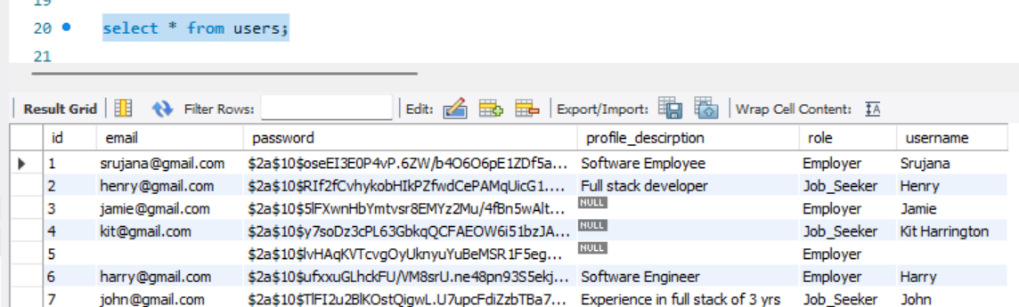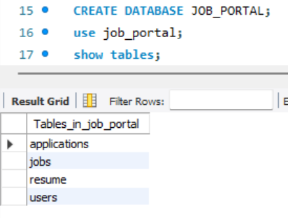

Users :-

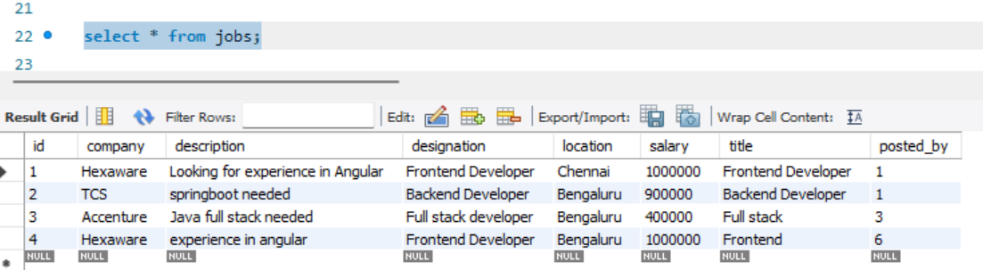Jobs

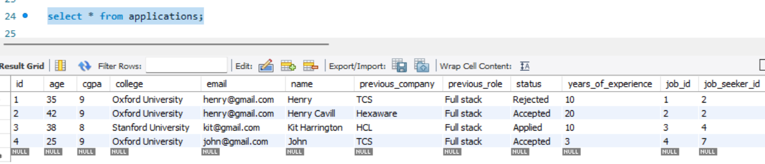Applications

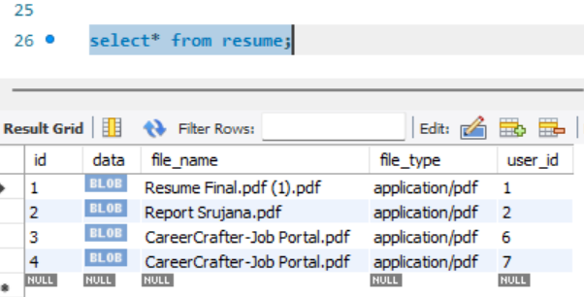Resumes